Bee: A Manual

1. Installing Bee

A. Downloading and Extracting Components
- Point your browser to http://www.vis-home.com/software/
- Create folder C:/Order_Processing (or name of your choice)
- Download the following files to the new folder: BeeInstallCand.exe, BeeSupport.exe, abc3xfull.exe, cuteprinter.exe.
- Double Click on every file and follow the directions. BeeInstallCand and BeeSupport should be extracted to C:/Order_Processing.

B. File Structure
    - Now your file structure should look like this (note the Advanced Batch Converter and CutePrinter folders):

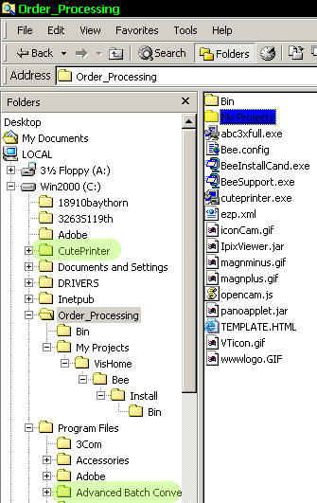

    - Now, create a Work_In_Progress folder inside the Order_Processing folder. Here we will store all the files we will use to create each individual Picture Plan

C. Bee Config
Although everything is installed, we have to make sure that Bee is properly configured. In order to do that, we may have to alter the Bee.config file. This will be discussed later.

2. Creating Floorplan
Will use property at 123 Anyhouse as an example

A. Generating an initial HPL.
- Create a new folder called 123anyhouse in the Work_In_Progress folder and copy all of the JPGS and FPLs of that house from the memory card into that house’s newly created folder.
- Run Bee by double clicking on Bee.exe
- Click on the File pull-down menu, and then click on “Create New House Plan.”
- Highlight all of the fpls that will make up the hpl. Note: to highlight more than one file, hold down CTRL while clicking your mouse.

B. Editing The Levels
Now that we created an HPL, we need to edit it so that it is aesthetically pleasing.
- Scale Up/Down – initially, the levels that make up the HPL should appear tiny. Don’t worry – use the buttons to make the levels bigger or smaller. Note: these buttons are at the right part of the tool bar, between the smiley face and arrow buttons. You can also use the View All command to alter the plan’s scale to see the whole plan. Click on the View pull-down menu , and than click on View All to activate that command.
- Rotating Levels – Now that we’ve changed the FPLs to suit us, we may need to rotate individual levels. To do that, go to that level’s FPL and its first room. Now use the left and right arrow keys on your keyboard to rotate the entire level
- Moving Levels – to move each level, simply click on it (make sure not to click inside empty space and not a label) and move the cursor while holding down the left mouse button.
- Edit Floorplans – Often times we realize that we need to edit the levels after we’ve already generated the HPL. To do that, minimize the HPL. You should now see the component FPLs which you can edit to your heart’s content, as you would using Tula. Note: make sure that once you’re done editing the FPLs you return to the overall view. Otherwise, when you click back to the HPL, it will look like this: 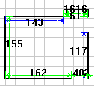

C. Room Labels
- Reset All Labels – Once we’ve made all the changes to the levels, chances
- are that we need to change our labels. To reset all the labels, click on the Edit pull-down menu, and click on Reset Labels.
- Changing Individual Labels – Besides wholesale changes, you can also change labels individually. Use the left mouse button to double-click on a label so that a dialog box will pop-up. The changes you make in that dialog box will be transferred to the label. Note: Make sure to click just above the very center of the label, otherwise Bee will think you want to create a new Label/Camera.
- Changing Label Fonts – Click on the Options button, located in the top right corner of the toolbox. An Output Options dialog button will pop-up. At the bottom left of that box there is a Label Font button. By pressing on that button, a Font dialog box will pop-up. You can manipulate the options in that box (just as you would in Microsoft Word) to change the font settings. Note: it is a good idea to Reset Labels (See II C 1) once you’ve made any changes to the label font.
- Moving Labels – to move a label, click once on it with the left mouse button and, while holding that button down, move the label. This is very similar to moving levels. Note: Just like in changing individual labels (Section II C 2), make sure to click just above the center of the label.
- Adding a New Label – double click on an empty area of the plan. A Camera/Label dialog box will pop-up. Select the Label tab. Type whatever you may wish into the top left section of that box.

D. Address Label
- Moving the Address Label – moving the address label around the plan is very similar to moving the labels or levels. Simply right-mouse-button click just above its center, and mo1. ve the cursor as you wish..
- Changing the Address Label – Click on the Info button (at the top right of the toolbar, just left of the Options button first mentioned in section II C 3). An Info dialog box will pop up, at the top right of which is the Picture Plan’s address. Make changes in that box according to your requirements, and those changes will be transferred onto the plan.

D. Level Labels
- Moving the Level Labels – move them as you would any other labels. Simply right-mouse-button click just above its center, and move the cursor as you wish.
- Changing the Level Labels - Click on the Info button (at the top right of the toolbar, just left of the Options button first mentioned in section II C 3). An Info dialog box will pop up, at the top left of which will be the names of all the levels. To edit a level name click once on it, wait half a beat, and click again. Now type in the new name.

3. Adding Images to Create a Picture Plan
  - Setting Up
    - Adjust the Bee window so that it takes up only a portion of the screen.
    - Use File Explorer to open C:/Order_Processing/Work_In_Progress/123anyhouse.
    - Set the View setting at the top to Thumbnails.
    - Adjust the explorer window so that it takes up the rest of the screen. The result should look something like this:
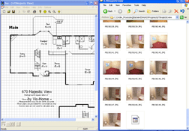
  - Adding Still Shots
1.Click on an image file in the Explorer window and drag it to the place of the plan. The following dialog box will pop up:
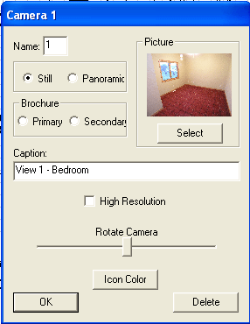
Note: If it does not, click anywhere on the Bee half of the screen.

2. You can rotate the camera so that it faces the correct direction by sliding the lever located just below the “Rotate Camera” caption.
3. If you need to, you can change that picture’s caption by altering the caption box
4. When you’re done, click OK
5. To move the camera, click and hold down the left mouse button and then move the camera.

  - Adding Panoramic Photos.
1 .Click on a panoramic image file in the Explorer window and drag it to the place of the plan. A Camera Dialog box will pop up.
2. Change the Picture Setting from Still to Panoramic Note: This menu is located inside the Camera Dialog box, left of the photo thumbnail.

  - Saving the HPL – once you’re done with all of the above steps, save the HPL by clicking on the button, at the left section of the toolbar. Make sure to save the HPL

4. Generating a Picture Plan from an HPL
A Picture Plan with many different features can be generated from an hpl. Conveniently, these are all gathered in the Options Menu:

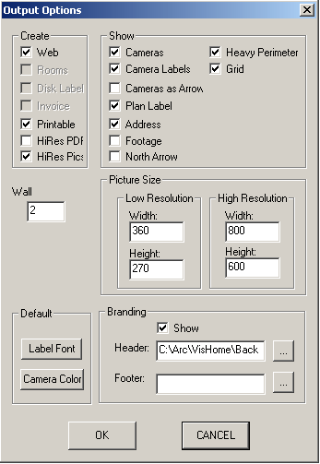

- Create – This section determines what deliverables will be made of this Picture Plan
- Web – an html version to be posted to the internet/MLS and used for CD Brochures
- Rooms
- Disk Label
- Invoice
- Printable – Creates a PDF of the floorplan and photographs which is linked to the web version
- HiRes PDF – alters the Printable version so that the PDF’s photographs are larger in size
- HiRes Pics – Adds a zoom-in feature to the Web version by linking each pop-up photo to a high-resolution version of itself.
- Show
- Cameras – shows/hides the camera icons on the Picture Plan
- Camera Labels – shows/hides the numbered labels of each camera icon
- Cameras as Arrows – changes camera icons on plan to arrow icons
- Plan Label – shows/hides the Vis-Home branding & disclaimer.
- Address – shows/hides the address label
- Footage – shows/hides “assessed footage” from Info box
- North Arrow – shows/hides compass arrow
- Heavy Perimeter – makes outside walls thicker than inside walls.
- Grid – shows/hides Grid

- Wall – allows you to determine a wall’s thickness, in inches
- Picture Size – changes the size of both the low-resolution pop-up photos and their magnified versions.
- Default
  - Label Font - By pressing on that button, a Font dialog box will pop-up. You can manipulate the options in that box (just as you would in Microsoft Word) to change the font settings. Note: it is a good idea to Reset Labels (See II C 1) once you’ve made any changes to the label font.
  - Camera Color – Lets you change the color of the camera icons

- Branding – this allows you to insert branding elements for your clients into their Picture Plans
1. Header – lets you define an HTML file which will be used to generate a header for the Picture Plan.
2. Footer - – lets you define an HTML file which will be used to generate a footer for the Picture Plan.

- Creating the Picture Plan – press the button to generate the Picture Plan. To select the target folder in which the Picture Plan will be generated, use the explorer window that pops up. Go inside the target folder (instead of just highlighting) and press OK.

5. Uploading Picture Plans
Automatic Upload
1.Press the button
2. Use the explore window to go inside the folder which you plan to upload.
3. Check to make sure that the Destination Folder Name path is correct
4. Press Select
5. If the Destination Folder does not already exist, the following menu should pop-up:
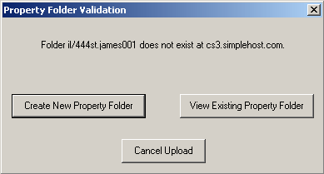

If everything is as it should be, press the , click to see a list of folders located in the same directory as the folder you were trying to create. Cancel is self-explanatory.

